Name : Evan Diantha Fafian

Class : SIB 2G

Absent : 09

NIM : 2341760163

**First Week OOP Report**

# Practicum Assignment

## Task 1

Take the following steps so that the practicum assignments carried out are systematic:

1. Define 1 category/class of objects. You can use a new object type or one of the objects from the PBO Theory task. For example: Bicycle

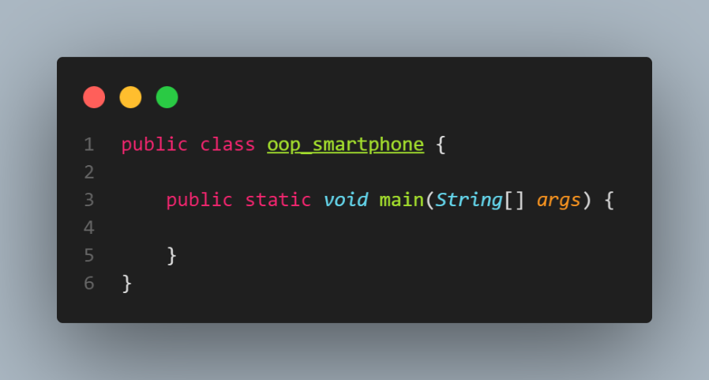

* + Here I create a class with the name oop_smartphone, here take the case for smartphones

1. Make observations of the object to determine
   * 3 variables/states/traits/states/values that can be had
   * 2 functions/behaviors/procedures/behaviors/processes that the object can perform

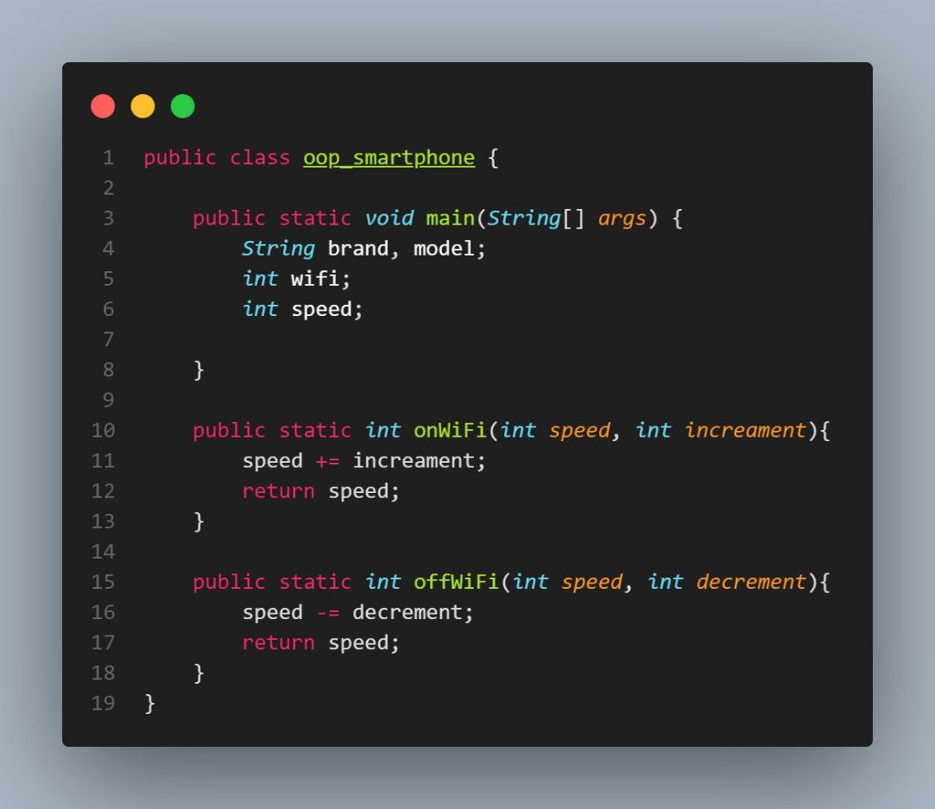

* + Here I use 4 variables namely brand, model, wifi, and speed. Then I have 2 functions namely onWiFi and offWiFi

1. Implement 10 objects of this type into a program with a **structural programming paradigm** (as in the bicycle example above)
   * Declare and initialize a variable for each characteristic/state/value of an object as a variable
   * Create a function of every procedure/behavior/process that can be performed by the object and then try to call the function/method

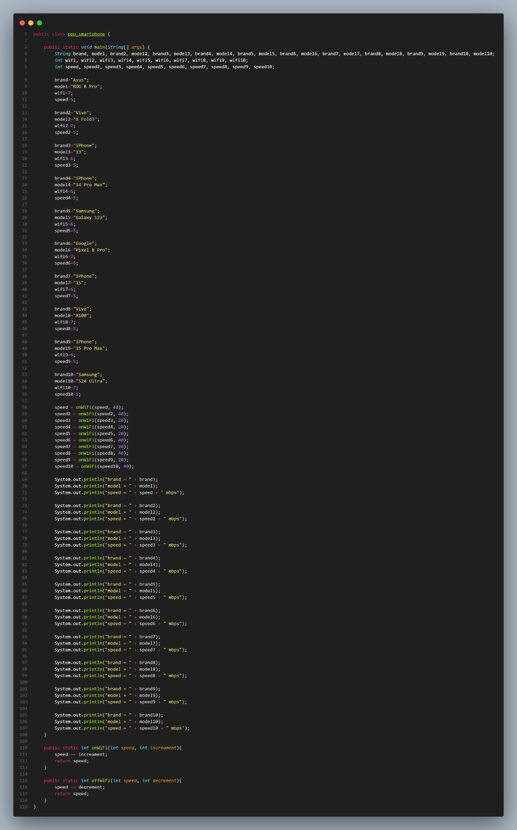

* + Here I declare and initialize the 4 variables that I have created. Here I do it to 10 objects

## Task 2

Create a simple calculator program with a **structural programming paradigm** that can accept the input of number1, operator, and number2 and display the results to the console/screen

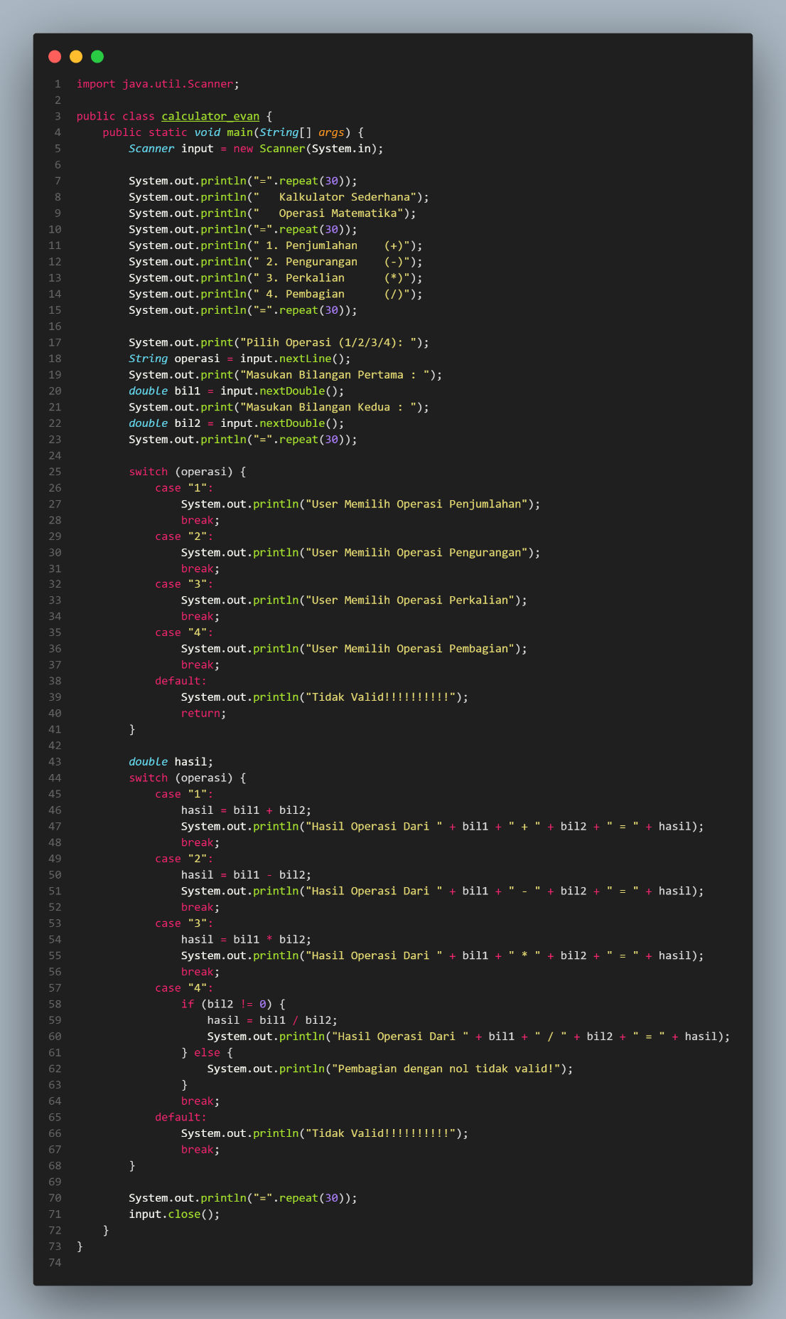

* + So here there is a calculator_evan class, here at first the user will be given 4 choices, namely addition, subtraction, multiplication, and finally division. If the user chooses an option that is not available in the menu, it will display the message “Invalid!!!!!” and will return to select the available menu. And in the division process, if the user enters the number 1 and number 2 which will produce invalid results, the message “Division with zero is invalid!!!!” will appear and will repeat again.